**HTML Page Structure**

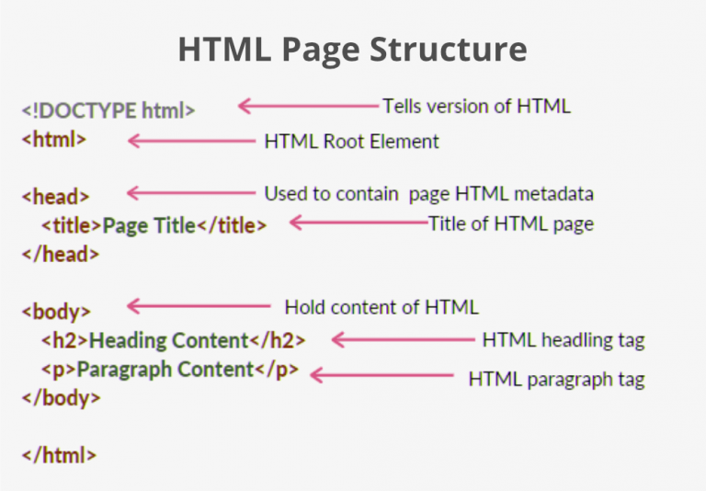

* [**<!DOCTYPE html>**](https://www.geeksforgeeks.org/html-doctypes/)**– This is the document type declaration, not a tag. It declares that the document is an HTML5 document.**
* [**<html>**](https://www.geeksforgeeks.org/html-html-tag/)**– This is called the HTML root element. All other elements are contained within it.**
* [**<head>**](https://www.geeksforgeeks.org/html-head-tag/)**– The head tag contains the “behind the scenes” elements for a webpage. Elements within the head aren’t visible on the front end of a webpage. Typical elements inside the <head> include:**
  + [**<title>**](https://www.geeksforgeeks.org/html-title-tag/)**: Defines the title displayed on the browser tab.**
  + [**<meta>**](https://www.geeksforgeeks.org/html-meta-tag/)**: Provides information like the character set or viewport settings.**
  + [**<link>**](https://www.geeksforgeeks.org/html-link-tag/)**: Links external stylesheets or resources.**
  + [**<style>**](https://www.geeksforgeeks.org/html-style-tag/)**: Embeds internal CSS styles.**
  + [**<script>**](https://www.geeksforgeeks.org/html-script-tag/)**: Embeds JavaScript for functionality.**
* [**<title>**](https://www.geeksforgeeks.org/html-title-tag/)**– The title is what is displayed on the top of your browser when you visit a website and contains the title of the webpage that you are viewing.**
* **<h2> – The <h2> tag is a second-level heading tag.**
* [**<p>**](https://www.geeksforgeeks.org/html-p-tag/)**– The <p> tag represents a paragraph of text.**
* [**<body>**](https://www.geeksforgeeks.org/html-body-tag/)**– The body tag is used to enclose all the visible content of a webpage. In other words, the body content is what the browser will show on the front end.**

**An HTML document can be created using an**[**HTML text editor**](https://www.geeksforgeeks.org/html-editors/)**. Save the text file using the “.html” or “.htm” extension. Once saved as an HTML document, the file can be opened as a webpage in the browser.**